Q1: SQL Query- SELECT id, year from productions WHERE title ~'Harry Potter' and attr is null and year>2011;

RA-

Result: 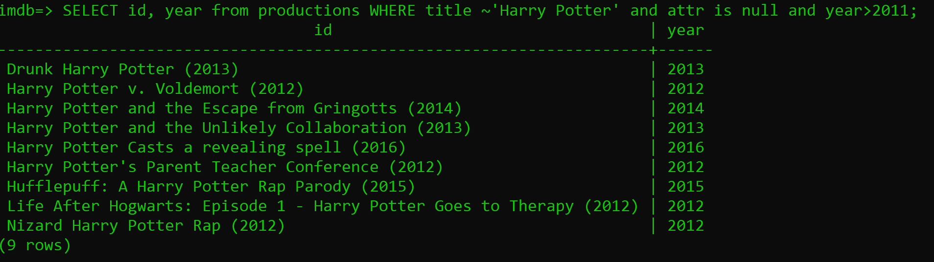

Q2: SQL Query- SELECT id FROM productions WHERE year>1980 and attr is null UNION SELECT character FROM roles WHERE pid= ‘Streep, Meryl’;

Result: